**Allgood Elementary School**

**Improvement at a Glance**

**Overview**

A School Improvement Plan (SIP) is a strategic guide that outlines goals and actions to boost student achievement and school performance. At Allgood Elementary, the mission, vision, and goals form the foundation for improvement efforts, promoting a unified and purposeful school culture. By aligning staff and resources with clear, measurable objectives, the SIP fosters a supportive and high-achieving learning environment for all students.

**Mission:**  Allgood Elementary School: Achieve, Excel, Succeed

**Vision:** The Vision of Allgood Elementary School is to have teachers, students, families, and the community working together to prepare lifelong learners through rigorous instruction in a supportive and respectful environment.

**Goals**

We will **increase teacher efficacy through collaboration** during the PLC process as **measured by an increase in student achievement** from 25% proficiency in ELA to 30% and an increase from 28% proficiency to 30% in Math by having teachers participate in professional development for weekly PLCs from August 2025-May 2026.

By the end of the 2025-2026 school year, we aim to **reduce the number of behavior incidents** resulting in in school isolation or out of school suspension from 112 in 2024-25 down to 105 **by continuing a Social Emotional Learning (SEL) program and PBIS**.

**Beliefs**

1. **Every child has the potential to achieve academic success** when provided with high expectations and meaningful support.
2. **Learning is a shared responsibility** among teachers, families, students, and the community, fostering a strong support system.
3. **All students deserve rigorous and engaging instruction** that challenges them to think critically and grow as lifelong learners.
4. **A respectful and inclusive environment** is essential for nurturing confidence, curiosity, and a love for learning in every child.
5. **Each child can excel and succeed** when their individual strengths, needs, and backgrounds are recognized and valued.

**Demographics**

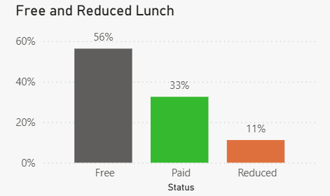

**FAQs**

***Is Allgood a Title I school?***

Yes; Allgood Elementary is a Title I school which receives additional funds to provide an equitable educational experience for our students compared to schools with populations experiencing a higher socioeconomic level.

***Do students have homework?***

No; Allgood students have tasks that can be performed at home daily, such as reading for 20 minutes or practicing math strategies through our learning management system. Our staff provides opportunities for parents to review skills with students, without taking grades for the work done at home.